**CMP4271: Online diary – Playtesting**

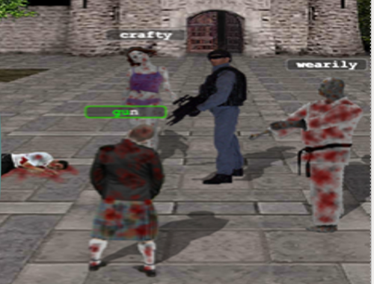**Introduction**

The task that was given to the team members was to playtest a game that they were supposed to find online. The name of the game was Typing of the Living Dead. It was a zombie killing type of game in which the player had to type words using a keyboard to kill the zombies that were coming towards them. As it can be seen on figure 1, this was the game that the team decided to use for the task.

**Materials**

The materials that the team members used to playtest the game were queries and questionnaires to accumulate data. The data consisted of feedback from the people in the class, based on their opinions of the game, whether they enjoyed it and/or found it educational.

Figure 1 (Gameplay)

**Rules**

* The player had to type a word using their keyboard to kill the zombie
* The words that were meant to be typed, appeared on top of the zombie’s heads
* By typing the word out, the character shoots the zombie, therefore the zombie dies
* If the player has killed X number of zombies, they move to a different level
* Each level progressively got harder with harder and longer words appearing on the screen

**Play Testing**

**Internal**

When the team decided to playtest the game, they found a couple of issues with it. For example, the player cannot lose the game and can keep playing until they have finished all the levels of the game. The group members proved that by not typing a single word and waited until the character in the game got overrun by the zombies. Even then, the character progressively kept shooting the zombies without any input from the player. With the lack of health bar or a timer that would indicate if the player is close to losing, the members of the team concluded that the game cannot be lost.

By further playtesting the words got more complicated and longer so a fast response was required from the player, however, with the inability to lose the game, the player did not feel stressed and took their time to type the words out.

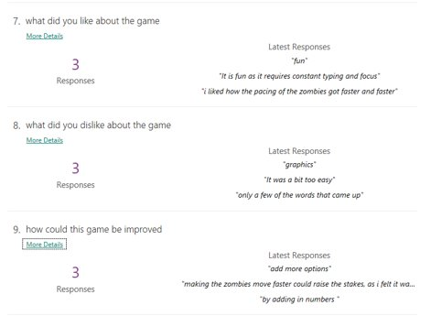**External**

For the external playtesting, the group members used questionnaires to gain information about the game from other people outside their group.  As it can be seen on figure 2, this was the feedback the group received from the class. Overall, the responses matched the team members opinion about the game being ‘’too easy”.

**Reflection**

When the team looked back on the game, they found things that can be improved. For example, introducing a losing condition and making better animations for the zombies, this would make the game much more entertaining for the users.

Figure 2 (Feedback)

**References:**

[**https://www.kongregate.com/games/ascott/typing-of-the-living-dead**](https://www.kongregate.com/games/ascott/typing-of-the-living-dead) **- A site from where the game could be played**